**CSE 2016 - Software Engineering Laboratory Project**

**ONLINE FASHOIN STORE**

**Prepared by:**

**ROICE VITHAYATHIL (20BCB7064) LEAD**

**K. LAKSHMI NARASIMHA REDDY (20BCB7069)**

**N. VISHNU PRABHAS REDDY (20BCB7103)**

**Team-10**

**OCT-2021**

**TABLE OF CONTENT**

|  |  |  |
| --- | --- | --- |
| **S.no** | **Title** | **Page.no** |
| **1** | 1.PROBLEM ANALYSIS  1.1Overview of the project  1.2Identification of project scope  1.3Objectives  1.4Infrastructure | **3-4** |
| **2** | 2. SOFTWARE REQUIREMENT ANALYSIS AND PLANNING  2.1 Description of individual phase/module  2.2 Identify individual module deliverables | **5 - 7** |
| **3** | 3. DATA MODELING  3.1 System Architecture Diagram  3.2 Simple use case diagram  3.3 Activity Diagram  3.4 DATA FLOW DIAGRAM  3.5 CLASS DIAGRAM | **8 - 11** |
| **4** | 4.DEVELOPMENT  4.1Database Structure | **12-13** |
| **5** | Source code | **14-36** |
| **6** | 5. TESTING  5.1 Test Plan  5.2. Test result and debugging | **37 - 40** |
| **7** | 6.Screenshots of the website | **40 - 44** |
| **8** | 7.References | **44** |

**1.PROBLEM ANALYSIS**

**1.1 Overview of the project**: This portal is mainly used to sell and purchase of clothes, different accessories

There are main users:  
a) Customers who purchases the products

b) Delivery partners

c) Sellers who sells their products through this portal

d) Admin (who manages the application)

**Why computerized or digitalized**

* The cons of offline shopping: less products than online, prices are higher compared to online
* The positive side making shopping online: customers can save time, customers can access the new fashions, variety of products from various places than offline shopping

**1.2 Identification of project scope:**

* introducing new fashions to customers: Through our online platform users can access various fashion trends.
* supporting new clothing startups: small scale startups are supported, promoted and sellers are easily to customers.
* Delivering customers quality products: Making sure our quality of our products is good

**Task involved:**

* Search engine: for displaying what the customers are searching
* Password and login management system: Saving the login details of users.
* Risk identification and rectification: We have to identify possible risks and rectify them.

Risks Involves:

-Delivery issues

-Product quality issues, etc.

* Database management system: Saving and securing information of users.
* Delivery management: Delivering the products in time.
* Customer services: Making sure all customer queries are answered.

**1.3 objectives**

* review section and customer services: valuing customer’s feedback and making sure customers problems are rectified
* quality products: making sure of product quality.
* convenient delivery: reliable and on time delivery services.
* introducing new trends: bringing in new trends based on fashion seasons.
* supporting new start-ups: promoting new companies along with known brands.
* Digitalizing our platform: most of the services are done online.
* advertising:

-promoting our platform

-promoting other companies

1.4 INFRASTRUCTURE

HTML, CSS

**2. SOFTWARE REQUIREMENT ANALYSIS AND PLANNING**

**2.1 Description of individual phase/module:**

**2.1.1 User characteristics**

**Admin:**

-Admin allows users to sell and buy products on their platform

- Calculating other user’s requirements and implementing them

-Admin controls overall operations of the system.

**Sellers:**

**-**Sellers can display, promote their products and sell them on this platform

-Sellers receive feedback from customers hence they can improve quality of products

**Customers:**

-Customers can search the products and place order.

- Customers can submit their review on products for others reference.

- Customers can track their product delivery status.

**Delivery partners:**

-Delivery partners can be aware the address of the customers to deliver a product

- Delivery partners can receive feedback from customers.

**2.1.2 General constraints:**

* Users should be aware of their respective id’s and passwords to access the services of the platform.
* Customers and delivery partners cannot change or update anything on platform.
* Customers cannot cancel or return the order after certain amount of time (based on product and seller)
* Delivery services are limited to some places.

**2.1.3 Assumption:**

* Every user knows English
* All users must know their id and password.
* Delivery services are not available for all the customers

**Dependency:**

* Offers and discounts can only be given when both admin and sellers agree.
* Sellers can only fix price when admin gives rights
* Delivery services depends on customer location

**2.1.4 Functional requirements:**

**1 Login and signup**

**Description:**

* Displays the welcome note of individual users

**Input:** Username and password of respective users.

**Output:** Depending upon input, the homepage displays for the user.

**2 Admin login**

**Description:**

* Gives access and privilege to respective roles.
* Enters plan, fix schedules and many more.

**Input:**

* List of products on the platform.
* giving access to other user’s information based on their role.

**Output:**

* Depending upon input of other users.
* approves or disapproves the functionality.

**3 Seller login**

**Description:**

* Accepts the orders.
* Ship the products to delivery partners.

**Input:**

* Displaying their products
* Giving updates on stock information
* Fixing or changing the price of the products.

**Output:**

* Information updates based on input.
* Receives feedback given by the customers.

**4 Customer Login**

**Description:**

* Gets access to product and delivery information.

**Input:**

* Searching for the products
* placing and tracking the orders based on customer interest
* giving payment details
* giving reviews or feedback on the products

**Output:**

* displays products based on users search
* Payment completion

**5 Delivery Partner Login**

**Description:**

* Access to customers address and order details.

**Input:** Updates delivery information

**Output:**

* Receives feedback given by customers.
* Address and delivery information of the customers.

**2.2 Identify individual module deliverables:**

**Login and signup module:**

* Login id and password is given as input for this page, if the password or login is correct then concerned homepage is shown for respective users.
* New users can sign up based on the information given they receive access from admin

**Admin module:**

* Gives access to other users based on their input.
* Have access to information of other users.

**Seller module:**

* Giving and updating product information.
* Receive feedback given by customers.

**Customer module:**

* Gets access to product information and delivery status.
* Can give feedback based on their experience.

**Delivery partner module:**

* Receives delivery information from the admin of the customer.
* Receive feedback given by customers.

**3. DATA MODELING**

**3.1 System Architecture Diagram:**

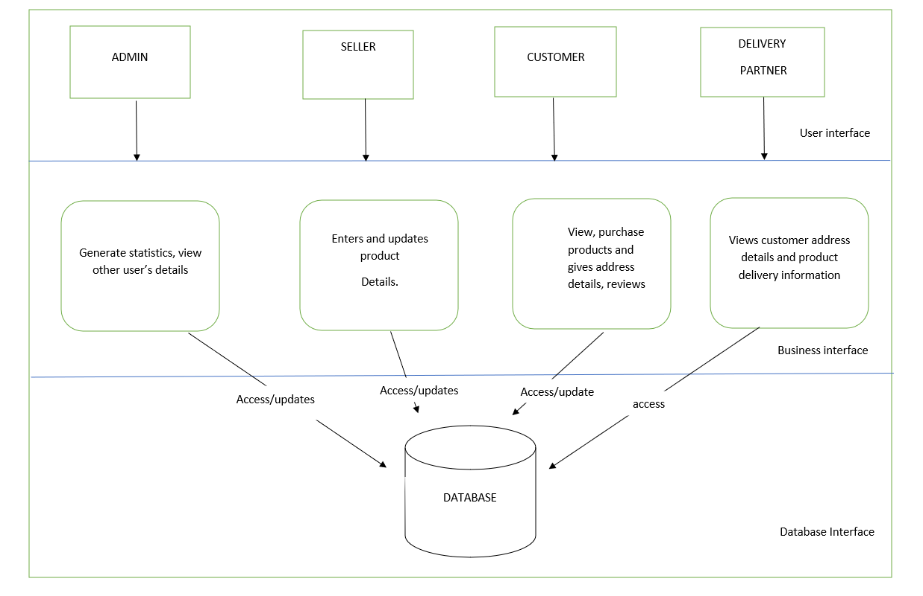**3.2 Simple use case diagram:**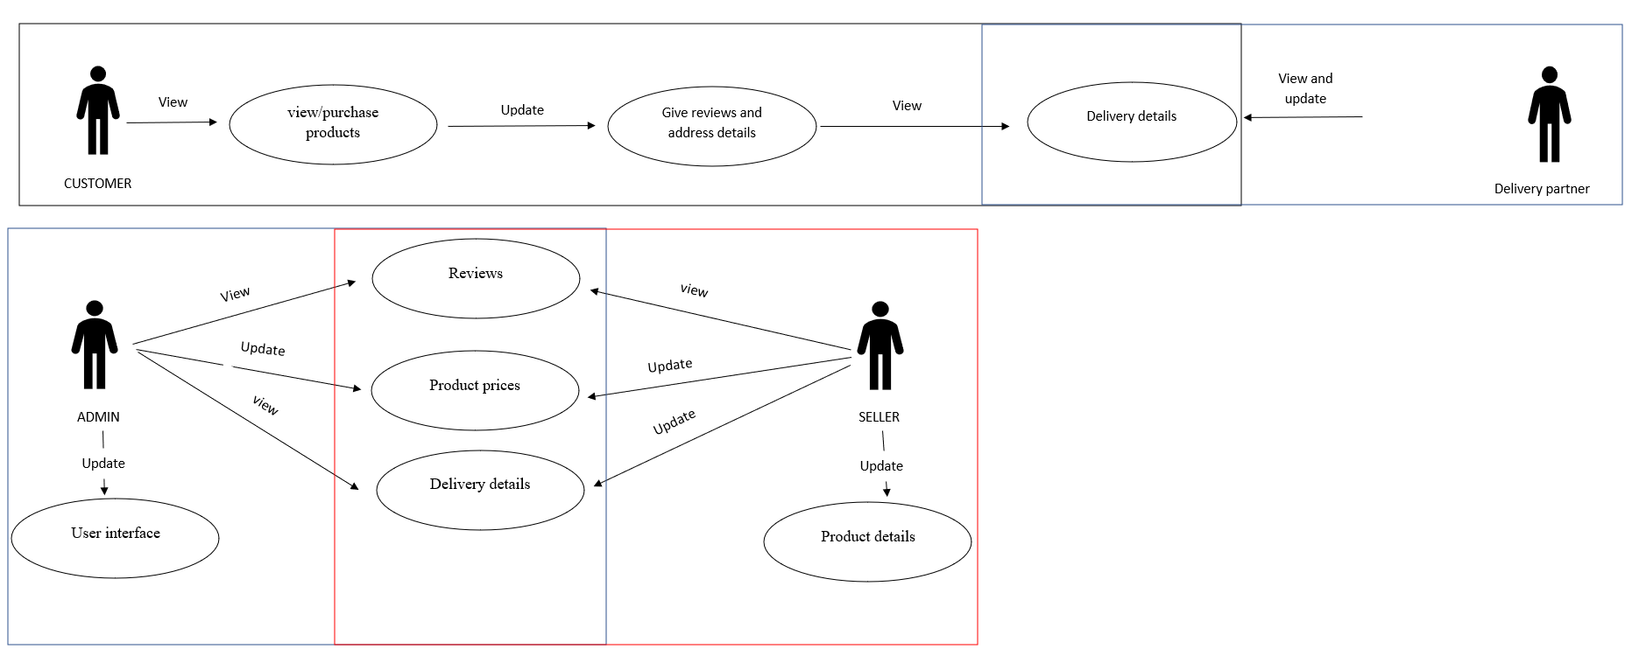

**3.3 Activity Diagram**

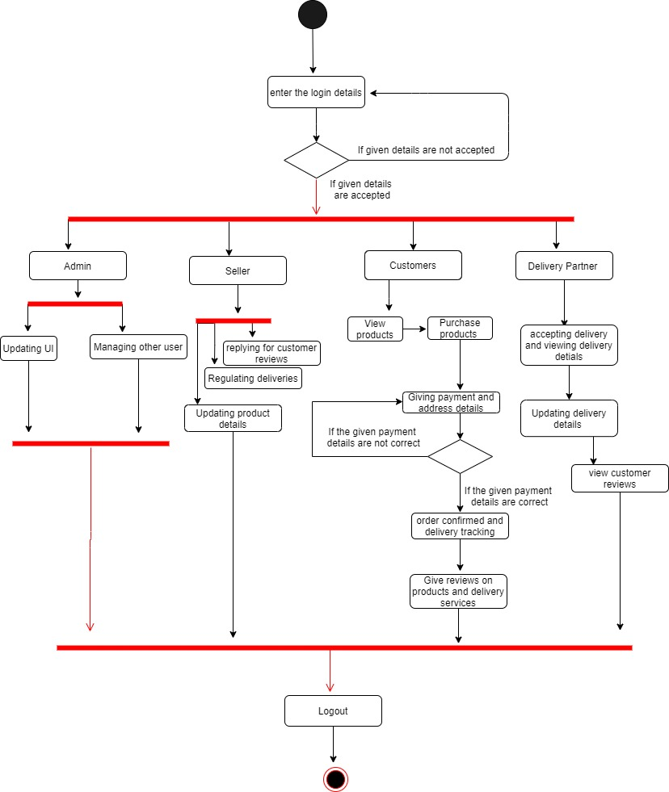

**3.4 DATA FLOW DIAGRAM:**

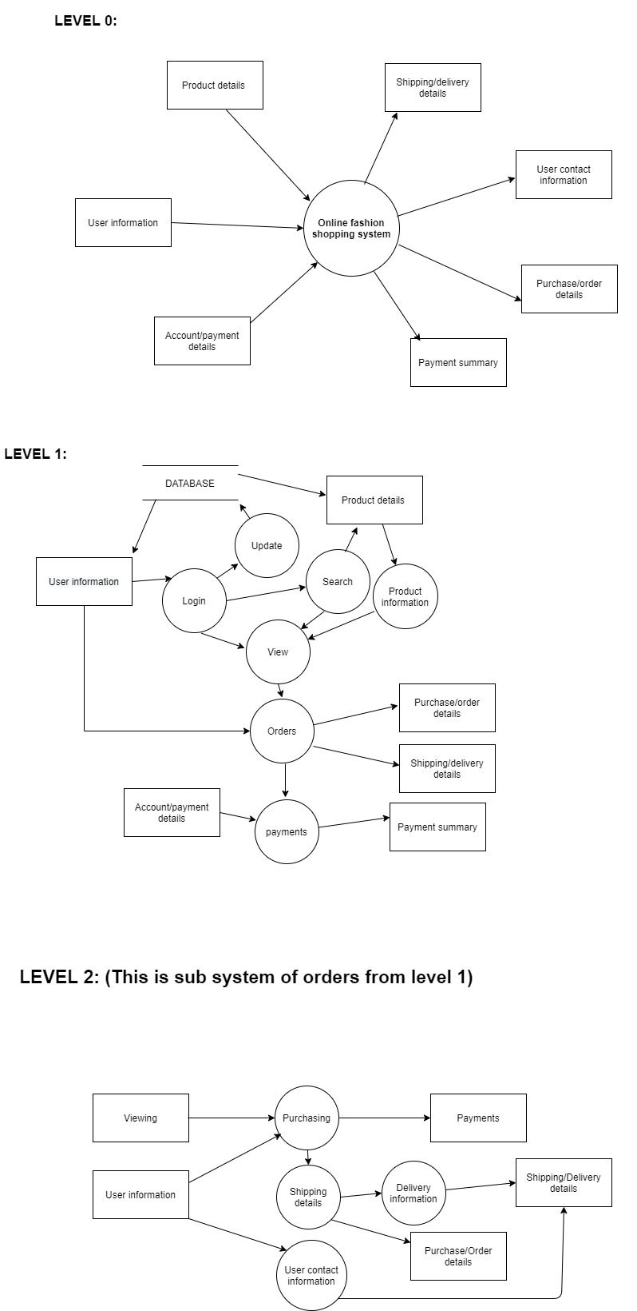

**3.5 CLASS DIAGRAM:**

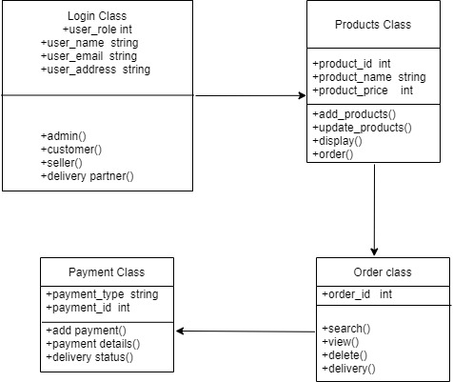

**4.DEVELOPMENT**

**4.1Database Structure**

**Login:**

|  |  |  |  |  |
| --- | --- | --- | --- | --- |
| FIELD | DATA TYPE | SIZE | CONSTRAINT | DESCRIPTION |
| User_id | Varchar2 | 15 | Primary key | A unique id that identifies the user |
| Password | Varchar2 | 10 | Not null | Password to the user enters in to home |

**Customer:**

|  |  |  |  |  |
| --- | --- | --- | --- | --- |
| FIELD | DATA TYPE | SIZE | CONSTRAINT | DESCRIPTION |
| Customer_contact_info | Varchar2 | 50 | Not null | Customer contact details like Email, ph.no are here |
| Customer_address | Varchar2 | 100 | Not null | Customer address details |
| Customer_reviews | Varchar2 | 100 | Not null | Reviews given by customer |
| Customer_interests | Varchar2 | 80 | Not null | Customer fashion intrests for better customer experience |
| Customer_id | Varchar2 | 15 | Primary key | A unique id that identifies the customer |

**Seller:**

|  |  |  |  |  |  |  |  |
| --- | --- | --- | --- | --- | --- | --- | --- |
| FIELD | DATA TYPE | SIZE | | | CONSTRAINT | | DESCRIPTION |
| product_details | Varchar2 | | 300 | Not null | | Details about product are mentioned | |
| product_prices | Number | | 10 | Primary key | | Product prices are updated | |
| Seller_ contact_info | Varchar2 | | 50 | Not null | | Seller contact information is stored | |
| Seller_id | Varchar2 | | 15 | Primary key | | A unique id that identifies the seller | |

**Delivery partner:**

|  |  |  |  |  |
| --- | --- | --- | --- | --- |
| FIELD | DATA TYPE | SIZE | CONSTRAINT | DESCRIPTION |
| Delivery_status | Varchar2 | 100 | Not null | Delivery status is updated |
| Partners_contact_info | Varchar2 | 80 | Not null | Delivery partner’s contact info |
| Partners_id | Varchar2 | 15 | Primary key | A unique id that identifies the delivery partner |

**Admin:**

|  |  |  |  |  |
| --- | --- | --- | --- | --- |
| FIELD | DATA TYPE | SIZE | CONSTRAINT | DESCRIPTION |
| Seller-id | Varchar2 | 15 | Foreign key | A unique id that identifies the seller |
| Admin_id | Varchar2 | 15 | Primary key | A unique id that identifies the user |
| Product_prices | Number | 10 | Foreign key | Product prices are updated |

**Source code: Used html and css**

**Login page:**

<html>

<head>

<meta charset="UTF-8">

<title center>Closet</title>

<link rel="icon"href="logo1.png"/>

<link rel="stylesheet" href="style.css">

<link rel="author"href="page1.html">

<head/>

<body>

<div class="login-box">

<img src="ava.png" class="ava">

<h1>Login</h1>

<form>

<p>Email</p>

<input type="text"name="Email" placeholder="Enter Email ID">

<p>password</p>

<input type="text"name="password" placeholder="password"><br><br>

<center>

<a href="page1.html" class="button">Login</a><br>

<a

href="#">Forgetpassword</a>

</center>

</form>

</div>

<body/>

<html>

**Css:**

body{

background: url(bed%201.jpg);

background-size: 1600px 800px;

background-position: center;

background-repeat: no-repeat;

font-family: sans-serif;

}

.login-box{

width: 420px;

height: 420px;

background: rgba(0, 0,0,0.5);

color: #fff;

top: 40%;

left: 50%;

position: absolute;

transform: translate(-50%,-50%);

box-sizing: border-box;

padding:70px 30px;

}

h1{

margin: 0;

padding:0 0 20px;

text-align: center;

font-size: 22px;

}

.login-box p{

margin: 0;

padding: 0;

font-weight: bold;

}

.login-box input{

width: 100%;

margin-bottom: 20px;

}

.login-box input[type="text"],input[type="password"]

{

border: none;

border-bottom: 2px solid #fff;

background: transparent;

outline: none;

height: 40px;

color: #fff;

font-size: 16px;

}

.ava{

height:100px;

width:100px;

border-radius: 40%;

position: absolute;

top: -30px;

left:calc(50% - 50px);

}

.button{

display: inline-block;

background: #ff523b;

color: #fff;

padding: 8px 30px;

margin: 30px 0;

border-radius: 30px;

transition: background;

}

**Home page:**

<html lang="en">

<head>

<mata charset="UTF-8">

<title>Closet</title>

<link rel="icon"href="logo1.png"/>

<link rel="stylesheet" href="main.css">

<link rel="stylesheet" href="https://cdn.jsdelivr.net/npm/@fortawesome/fontawesome-free@5.15.4/css/fontawesome.min.css">

<head/>

<body>

<div class="fullcolor">

<div class="container">

<div class="navbar">

<div class="logo1">

<img src="logo1.png" width="150px" height="90px">

</div>

<nav>

<ul>

<li><a href="" class="button">Home</a></li>

<li><a href="" class="button">About</a></li>

<li><a href="" class="button">Contact</a></li>

<li><a href="closet.html" class="button">Login</a></li>

</ul>

</nav>

<img src="https://img.icons8.com/ios-filled/50/000000/menu--v1.png" class="menu-icon">

</div>

<div class="header">

<div class="row">

<div class="col-2">

<h1>shop at the<br>best destination for fashion</h1>

<p></p>

<div class="point">

<li><a harf="" class="button">Explore Now &#8594;</a></li>

</div>

</div>

<div class="col-2">

<img src="D.png">

</div>

</div>

</div>

</div>

</div>

<!----->

<div class="categories">

<div class="small-container">

<div class="row">

<div class="col-3">

<img src="image/jeans-1234687_640.jpg" height="400px" width="300px">

</div>

<div class="col-3">

<img src="image/shirt-2604757_640.jpg" height="400px" width="300px">

</div>

<div class="col-3">

<img src="image/title-1587325_640.jpg" height="400px" width="300px">

</div>

</div>

</div>

</div>

<!---prodect-->

<div class="small-container">

<center>

<h2 class="title">confused on what to Buy</h2>

</center>

<div class="row">

<div class="col-4">

<img src="image/sandil.jpg" width="427px" height="280px">

<h4>Red sandles</h4>

<p>Rs2199</p>

<a href="page2.html" class="button">Buy Now</a>

<div class="rating">

<i class="fas fa-star"></i>

<i class="fas fa-star"></i>

<i class="fas fa-star"></i>

<i class="fas fa-star"></i>

<i class="far fa-star"></i>

</div>

</div>

<div class="col-4">

<img src="image/woman-3083383_640.jpg" width="427px" height="280px" >

<h4>shirt for woman</h4>

<p>Rs.1299</p>

<a href="page3.html" class="button">Buy Now</a>

<div class="rating">

<i class="fas fa-star"></i>

<i class="fas fa-star"></i>

<i class="fas fa-star"></i>

<i class="fas fa-star-o"></i>

<i class="far fa-star-o"></i>

</div>

</div><div class="col-4">

<img src="image/feet-1840619_640.jpg"

width="427px" height="280px">

<h4>nike shoes</h4>

<p>Rs.9000</p>

<a href="page4.html" class="button">Buy Now</a>

<div class="rating">

<i class="fas fa-star"></i>

<i class="fas fa-star"></i>

<i class="fas fa-star"></i>

<i class="fas fa-star"></i>

<i class="far fa-star"></i>

</div>

</div><div class="col-4">

<img src="image/shoes-1897708_640.jpg" width="427px" height="280px">

<h4>shoes</h4>

<p>Rs.8000</p>

<li><a href="page5.html" class="button">Buy Now</a></li>

<div class="rating">

<i class="fas fa-star"></i>

<i class="fas fa-star"></i>

<i class="fas fa-star"></i>

<i class="fas fa-star"></i>

<i class="fas fa-star-o"></i>

</div>

</div>

</div>

<center>

<h2 class="title">Latest Products</h2>

</center>

<!--first line--->

<div class="row">

<div class="col-4">

<img src="image/t-shirt-2068353_640.png" width="427px" height="280px">

<h4>blue sweatshirt</h4>

<p>Rs.1298</p>

<li><a href="page6.html" class="button">Buy Now</a></li>

<div class="rating">

<i class="fas fa-star"></i>

<i class="fas fa-star"></i>

<i class="fas fa-star"></i>

<i class="fas fa-star"></i>

<i class="far fa-star"></i>

</div>

</div>

<div class="col-4">

<img src="image/john-torcasio-TJrkkhdB39E-unsplash.jpg" width="427px" height="280px" >

<h4>wrist watch</h4>

<p>Rs.18000</p>

<li><a href="page7.html" class="button">Buy Now</a></li>

<div class="rating">

<i class="fas fa-star"></i>

<i class="fas fa-star"></i>

<i class="fas fa-star"></i>

<i class="fas fa-star-o"></i>

<i class="far fa-star-o"></i>

</div>

</div><div class="col-4">

<img src="image/revolt-164_6wVEHfI-unsplash.jpg"

width="427px" height="280px">

<h4>Nike red shoes</h4>

<p>Rs.8000</p>

<li><a href="" class="button">Buy Now</a></li>

<div class="rating">

<i class="fas fa-star"></i>

<i class="fas fa-star"></i>

<i class="fas fa-star"></i>

<i class="fas fa-star"></i>

<i class="far fa-star"></i>

</div>

</div><div class="col-4">

<img src="image/radek-skrzypczak-WlB8TsI_th0-unsplash.jpg" width="427px" height="280px">

<h4>Brown leather shoes</h4>

<p>Rs.6000</p>

<li><a href="" class="button">Buy Now</a></li>

<div class="rating">

<i class="fas fa-star"></i>

<i class="fas fa-star"></i>

<i class="fas fa-star"></i>

<i class="fas fa-star"></i>

<i class="fas fa-star-o"></i>

</div>

</div>

</div>

<!--second line--->

<div class="row">

<div class="col-4">

<img src="image/jaelynn-castillo-xfNeB1stZ_0-unsplash.jpg" width="427px" height="280px">

<h4>women's wrist ware</h4>

<p>Rs.7998</p>

<li><a href="" class="button">Buy Now</a></li>

<div class="rating">

<i class="fas fa-star"></i>

<i class="fas fa-star"></i>

<i class="fas fa-star"></i>

<i class="fas fa-star"></i>

<i class="far fa-star"></i>

</div>

</div>

<div class="col-4">

<img src="image/pixel-bee-u8isJQ6QjF4-unsplash.jpg" width="427px" height="280px" >

<h4>Rolex watch</h4>

<p>Rs.13999</p>

<li><a href="" class="button">Buy Now</a></li>

<div class="rating">

<i class="fas fa-star"></i>

<i class="fas fa-star"></i>

<i class="fas fa-star"></i>

<i class="fas fa-star-o"></i>

<i class="far fa-star-o"></i>

</div>

</div><div class="col-4">

<img src="image/shoes-153310_640.png"

width="427px" height="280px">

<h4>converse shoes</h4>

<p>Rs.15000</p>

<li><a href="" class="button">Buy Now</a></li>

<div class="rating">

<i class="fas fa-star"></i>

<i class="fas fa-star"></i>

<i class="fas fa-star"></i>

<i class="fas fa-star"></i>

<i class="far fa-star"></i>

</div>

</div><div class="col-4">

<img src="image/wengang-zhai-_fOL6ebfECQ-unsplash.jpg" width="427px" height="280px">

<h4>red shoes</h4>

<p>Rs.9998</p>

<li><a href="" class="button">Buy Now</a></li>

<div class="rating">

<i class="fas fa-star"></i>

<i class="fas fa-star"></i>

<i class="fas fa-star"></i>

<i class="fas fa-star"></i>

<i class="fas fa-star-o"></i>

</div>

</div>

</div>

<!---third---->

<div class="row">

<div class="col-4">

<img src="image/benjamin-rascoe-SZoTel1Y4qc-unsplash.jpg" width="427px" height="280px">

<h4>three piece for men</h4>

<p>Rs.15998</p>

<li><a href="" class="button">Buy Now</a></li>

<div class="rating">

<i class="fas fa-star"></i>

<i class="fas fa-star"></i>

<i class="fas fa-star"></i>

<i class="fas fa-star"></i>

<i class="far fa-star"></i>

</div>

</div>

<div class="col-4">

<img src="image/benjamin-rascoe-Z3N7m_r02TA-unsplash.jpg" width="427px" height="280px" >

<h4>suit for men</h4>

<p>Rs.12000</p>

<li><a href="" class="button">Buy Now</a></li>

<div class="rating">

<i class="fas fa-star"></i>

<i class="fas fa-star"></i>

<i class="fas fa-star"></i>

<i class="fas fa-star-o"></i>

<i class="far fa-star-o"></i>

</div>

</div><div class="col-4">

<img src="image/shirt-2605698_640.jpg"

width="427px" height="280px">

<h4>white shirt</h4>

<p>Rs.1899</p>

<li><a href="" class="button">Buy Now</a></li>

<div class="rating">

<i class="fas fa-star"></i>

<i class="fas fa-star"></i>

<i class="fas fa-star-o"></i>

<i class="fas fa-star-o"></i>

<i class="far fa-star-o"></i>

</div>

</div><div class="col-4">

<img src="image/santhosh-kumar-RqYTuWkTdEs-unsplash.jpg" width="427px" height="280px">

<h4>shirt</h4>

<p>Rs.2000</p>

<li><a href="" class="button">Buy Now</a></li>

<div class="rating">

<i class="fas fa-star"></i>

<i class="fas fa-star"></i>

<i class="fas fa-star"></i>

<i class="fas fa-star-o"></i>

<i class="fas fa-star-o"></i>

</div>

</div>

</div>

<center>

<h2 class="title">T-Shirts</h2>

</center>

<div class="row">

<div class="col-4">

<img src="image/alex-haigh-fEt6Wd4t4j0-unsplash.jpg" width="427px" height="280px">

<h4>T-shirt</h4>

<p>Rs500</p>

<li><a href="" class="button">Buy Now</a></li>

<div class="rating">

<i class="fas fa-star"></i>

<i class="fas fa-star"></i>

<i class="fas fa-star"></i>

<i class="fas fa-star"></i>

<i class="far fa-star-o"></i>

</div>

</div>

<div class="col-4">

<img src="image/ryan-hoffman-6Nub980bI3I-unsplash.jpg" width="427px" height="280px" >

<h4>Black shirt</h4>

<p>Rs.800</p>

<li><a href="" class="button">Buy Now</a></li>

<div class="rating">

<i class="fas fa-star"></i>

<i class="fas fa-star"></i>

<i class="fas fa-star"></i>

<i class="fas fa-star"></i>

<i class="far fa-star-o"></i>

</div>

</div><div class="col-4">

<img src="image/florencia-simonini-PDZAMYvduVk-unsplash.jpg"

width="427px" height="280px">

<h4>white T-shirt</h4>

<p>Rs.900</p>

<li><a href="" class="button">Buy Now</a></li>

<div class="rating">

<i class="fas fa-star"></i>

<i class="fas fa-star"></i>

<i class="fas fa-star"></i>

<i class="fas fa-star"></i>

<i class="far fa-star-o"></i>

</div>

</div><div class="col-4">

<img src="image/faith-yarn-Wr0TpKqf26s-unsplash.jpg" width="427px" height="280px">

<h4>stylish black T-shirt</h4>

<p>Rs.800</p>

<li><a href="" class="button">Buy Now</a></li>

<div class="rating">

<i class="fas fa-star"></i>

<i class="fas fa-star"></i>

<i class="fas fa-star"></i>

<i class="fas fa-star-o"></i>

<i class="fas fa-star-o"></i>

</div>

</div>

</div>

</div>

<body/>

<html/>

**Css:**

*{

margin: 0;

padding: 0;

box-sizing: border-box;

}

.navbar{

display: flex;

align-items: center;

padding-left: 100px;

}

nav{

flex: 1;

text-align: right;

}

nav ul{

display: inline-block;

list-style-type: none;

}

nav ul li{

display: inline-block;

margin-right: 10px;

}

.a{

text-decoration: none;

color: #555;

}

.p{

color: #555;

}

.container{

max-width: 3000px;

margin: auto;

padding-right:1px;

padding-left: 1px;

}

.row{

display: flex;

align-items: center;

flex-wrap: wrap;

justify-content: space-around;

}

.col-2{

flex-basis: 35%;

min-width: 100px;

}

.col-2 img{

max-width: 100%;

padding: 10px 0;

}

.button{

display: inline-block;

background: #ff523b;

color: #fff;

padding: 8px 30px;

margin: 30px 0;

border-radius: 30px;

transition: background;

}

.button:hover{

background: #563535;

}

.header{

background: radial-gradient(#82b74b,#82b74b)

}

.fullcolor{

background: radial-gradient(#fff,#ffd6d6)

}

.point{

list-style-type: none;

display: inline-block;

}

.header .row{

margin-top: 70px;

}

.categories{

margin: 70px 0;

}

.col-3{

flex-basis: 30%;

min-width: 250px;

margin-bottom: 30px;

}

.col-3 img{

width: 100%;

}

.small-container{

max-width: 1080px;

margin: auto;

padding-left: 25px;

padding-right: 25px;

}

.col-4{

flex-basis: 25%;

padding: 10px;

min-width: 200px;

margin-bottom: 50px;

transition: transform 0.5s;

}

.col-4 img{

width: 100%;

}

.title{

margin: 0 auto 80px;

position: relative;

line-height: 60px;

color: #555;

}

.title::after{

content:"";

background: #ff523b;

width: 80px;

height: 5px;

border-radius: 5px;

position: absolute;

bottom: 0;

left: 50%;

transform: translate(-50%);

}

h4{

color: #555;

font-weight: normal;

}

.col-4 p{

font-size: 14px;

}

.col-4:hover{

transform: translateY(-10px);

}

.menu-icon{

width: 28px;

margin-left: 20px;

}

@media only screen and (max-width:800px){

nav ul{

position: absolute;

top:90px;

left: 0;

background: #333;

width: 110px;

}

nav ul li{

display: block;

margin-right: 50px;

margin-top: 10px;

margin-bottom: 10px;

}

}

**Buy now button pressed:**

<html lang="en">

<head>

<mata charset="UTF-8">

<title>Closet</title>

<link rel="icon"href="logo1.png"/>

<link rel="stylesheet" href="pg2.css">

<link rel="stylesheet" href="https://cdn.jsdelivr.net/npm/@fortawesome/fontawesome-free@5.15.4/css/fontawesome.min.css">

<head/>

<body>

<div class="navbar">

<div class="logo1">

<img src="logo1.png" width="150px" height="90px">

</div>

<nav>

<ul>

<li><a href="page1.html" class="button">Home</a></li>

<li><a href="" class="button">About</a></li>

<li><a href="" class="button">Contact</a></li>

<li><a href="closet.html" class="button">Login</a></li>

</ul>

</nav>

</div>

<div class="row">

<div class="col">

<img src="image/sandil.jpg">

<h4>Red sandle for women</h4>

<p>Rs2199</p>

</div>

</div>

<div class="custmerdetails">

<center>

<p>First name</p>

<input type="text"name="First name" placeholder="Enter first name">

<p>Last name</p>

<input type="text"name="Last name" placeholder="Enter Last name">

<p>Email</p>

<input type="text"name="Email" placeholder="Enter Email ID">

<p>Phone no</p>

<input type="text"name="Phone no" placeholder="Enter Phone number">

<p>address</p>

<input type="text"name="address" placeholder="Enter the address">

<center>

<a href="" class="button">Submit</a><br>

<a

href="#">Forgetpassword</a>

</center>

</center>

</div>

<body/>

<html/>

**Css**

*{

margin: 0;

padding: 0;

box-sizing: border-box;

}

.navbar{

display: flex;

align-items: center;

padding: 20px;

}

nav{

flex: 1;

text-align: right;

}

nav ul{

display: inline-block;

list-style-type: none;

}

nav ul li{

display: inline-block;

margin-right: 10px;

}

.a{

text-decoration: none;

color: #555;

}

.p{

color: #555;

}

.row{

display: flex;

align-items: center;

flex-wrap: wrap;

justify-content: space-around;

}

.col{

flex-basis: 35%;

min-width: 100px;

}

.col img{

max-width: 100%;

padding: 10px 0;

}

.button{

display: inline-block;

background: #ff523b;

color: #fff;

padding: 8px 30px;

margin: 30px 0;

border-radius: 30px;

transition: background;

}

.button:hover{

background: #563535;

}

h4{

color: #555;

font-weight: normal;

}

**5. TESTING**

**5.1 Test Plan:**

**Test case id:**342

**Unit to test:** Login

**Assumptions:** Login process is successfully done.

**Test data:** User id = {valid, invalid, empty, valid email, Invalid email}

Password: {valid, invalid, empty}

**Steps to be executed:**

* + Login page to the displayed.
  + User id is given in the text box.
  + Password is given in the text box.
  + Login button is viewed.
  + Click the login button.
  + Verify corresponding information and welcome with home page.

**Expected result:**

* View login page.
* Open home page after pressing on login button.
* Display the home page only after verifying the given login details.

**Actual result:**

* Viewing the login page.
* Opens home page after pressing the login button.
* Displaying the home page without verifying the given login details.

**Pass/Fail:** Fail

**Comment:** Home page should open only when correct login details were given but here home page is being accessed with no regard of login details.

**Test case id:343**

**Unit to test:** Buy now

**Assumptions:** After pressing on the button, it will the page where we can update our information delivery details.

**Test data:**

Buy now button

**Steps to be executed:**

* Products are being displayed.
* Click on buy now button under the product we want to buy.
* Later it should open the address update page,

**Expected result:** Open address update page after clicking on buy now button

**Actual result:** Address page is opening after clicking on buy now button

**Pass/Fail:** Pass

**Comment:** No changes to be done in this test case

**Test case id:344**

**Unit to test:** Contact Us

**Assumptions:** Contact information should be visible when clicked on this button**.**

**Test data:**

Contact us button

**Steps to be executed:** Click on contact us button which displays contact information

**Expected result:**

* Contact us should be visible on home
* When clicked on button contact information should be displayed

**Actual result:**

* Contact us button is visible on home page
* Contact information is displayed when clicked on contact us button

**Pass/Fail:** Pass

**Comment:** No changes to be done in this test case

**Test case id:345**

**Unit to test:** Updating address

**Assumptions:** Customer can update their information and delivery address details.

**Test data:**

First name:

Last name:

Email:

Phone no:

Address:

**Steps to be executed:**

* + Address update page to the displayed.
  + Email is given in the text box.
  + Address is given in the text box.
  + Mobile number is given in the text box.
  + First name is given in the text box.
  + Last name is given in the text box.
  + Submit button is viewed.
  + Click the Submit button.
  + Update corresponding information and give access to payment page.

**Expected result:**

* Text boxes should be filled.
* After clicking on submit button corresponding details should be updated in date base.
* Payment page should be displayed

**Actual result:**

* Text boxes can be filled.
* Given details are not getting updated to the data base after clicking on submit button.
* Payment page is not being displayed

**Pass/Fail:** Fail

**Comment:** Details given in text boxes should be updated to database and payment page should be displayed after clicking on submit button

**Test case id:346**

**Unit to test:** Home

**Assumptions:** Home page should open after clicking on home button.

**Test data:**

Home button

**Steps to be executed:**

* Press home page button
* Home page with product information should be displayed

**Expected result:** Home page should open after clicking on home button.

**Actual result:** After clicking on home button, home page is displayed.

**Pass/Fail:** Pass

**Comment:** No changes to be done in this test case

**5.2. Test result and debugging:**

|  |  |  |  |  |
| --- | --- | --- | --- | --- |
| **Serial no** | **Test case id** | **Test case name** | **Pass/Fail** | **If fail comment on it** |
| **1** | 342 | login | Fail | Home page should be able to access only when correct login details are given |
| **2** | 343 | Buy now | Pass | _ |
| **3** | 344 | Updating address | Fail | Details given in text boxes should be updated to database and payment page should be displayed after clicking on submit button |
| **4** | **345** | **Contact us** | **Pass** | **_** |
| **5** | **346** | **Home** | **Pass** | **_** |

**6.Screenshots of the website:**

**Screenshot of login page:**

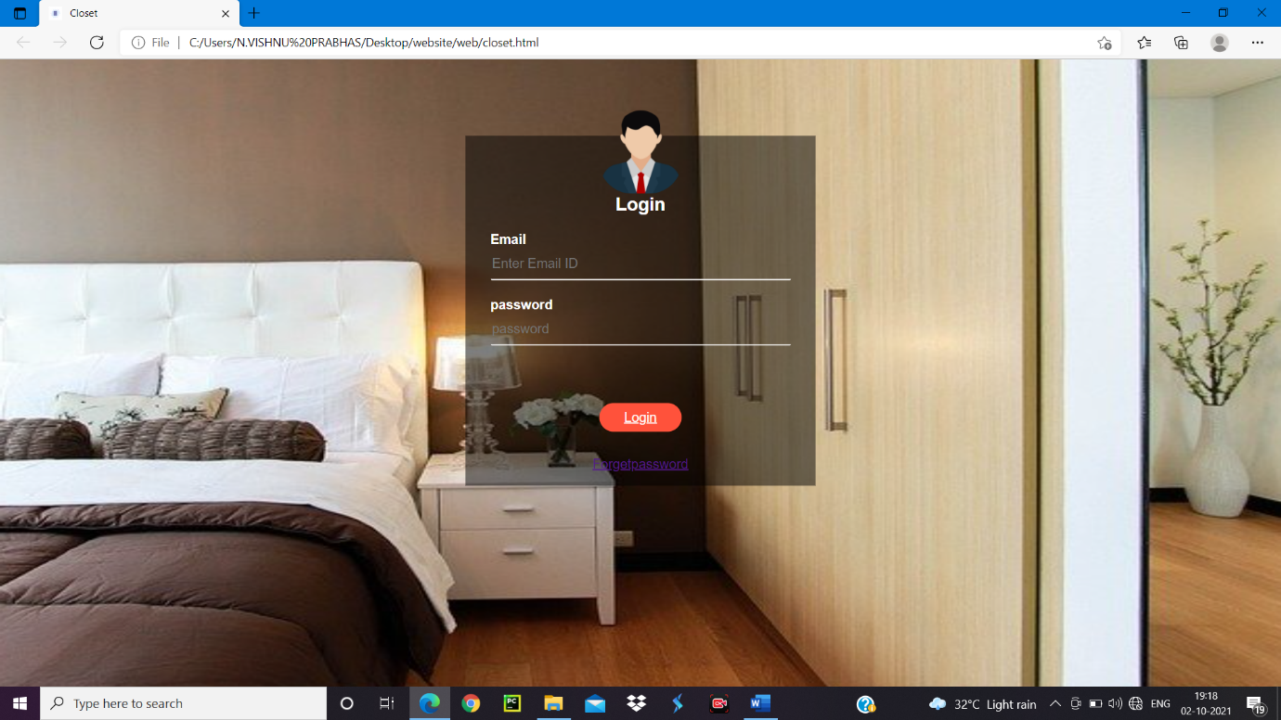

**Screenshot of home page of website:**

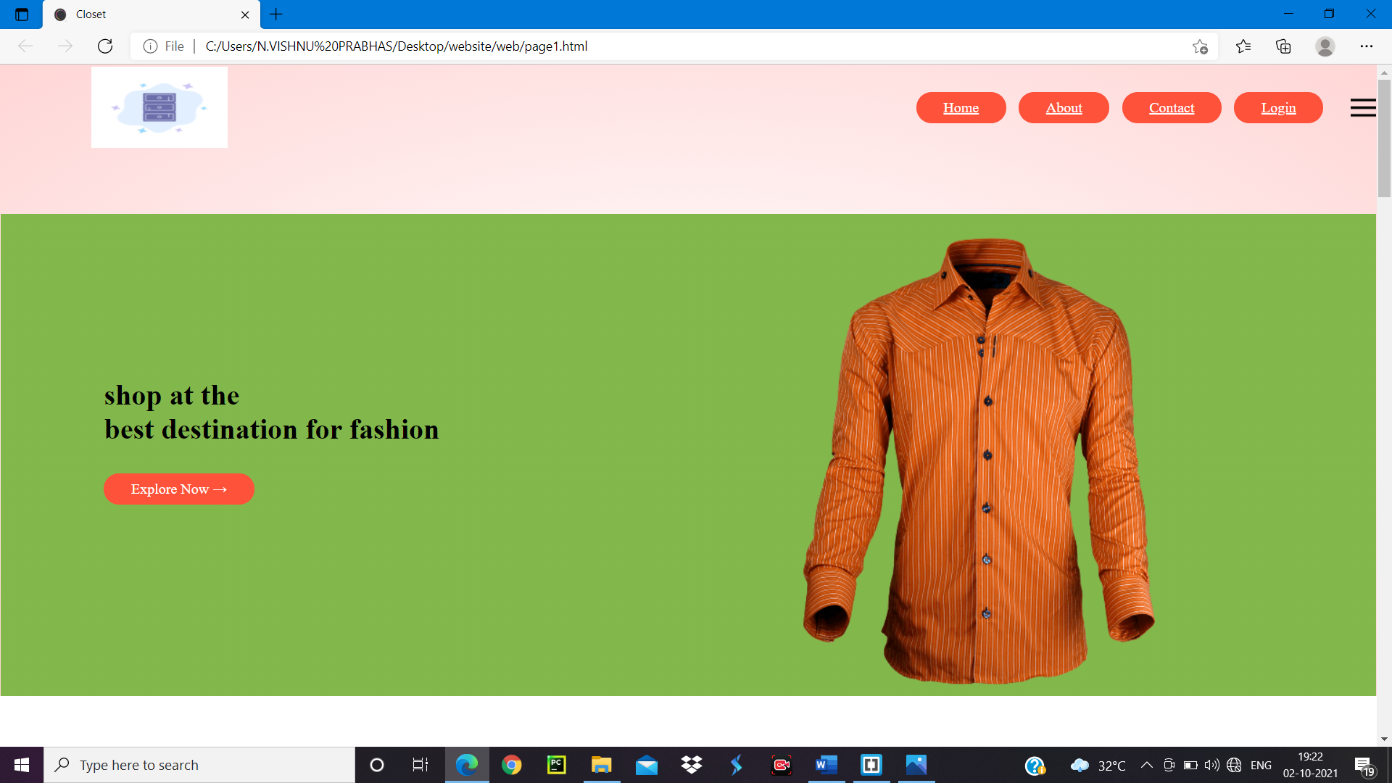

**Few screenshots of product display page:**

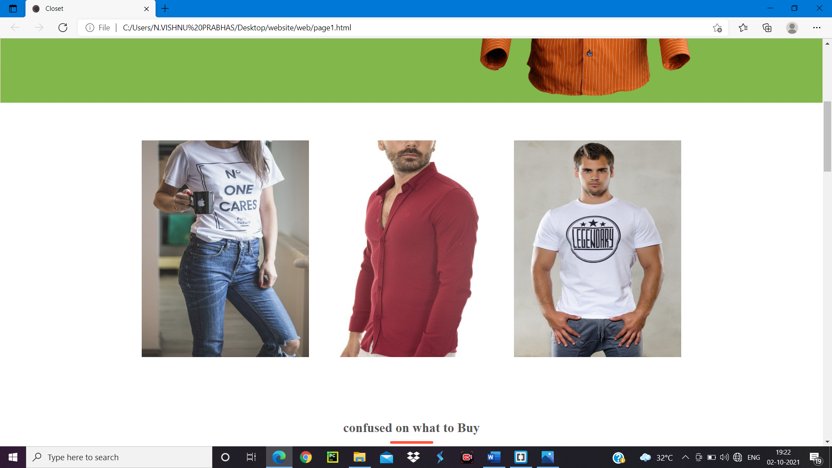

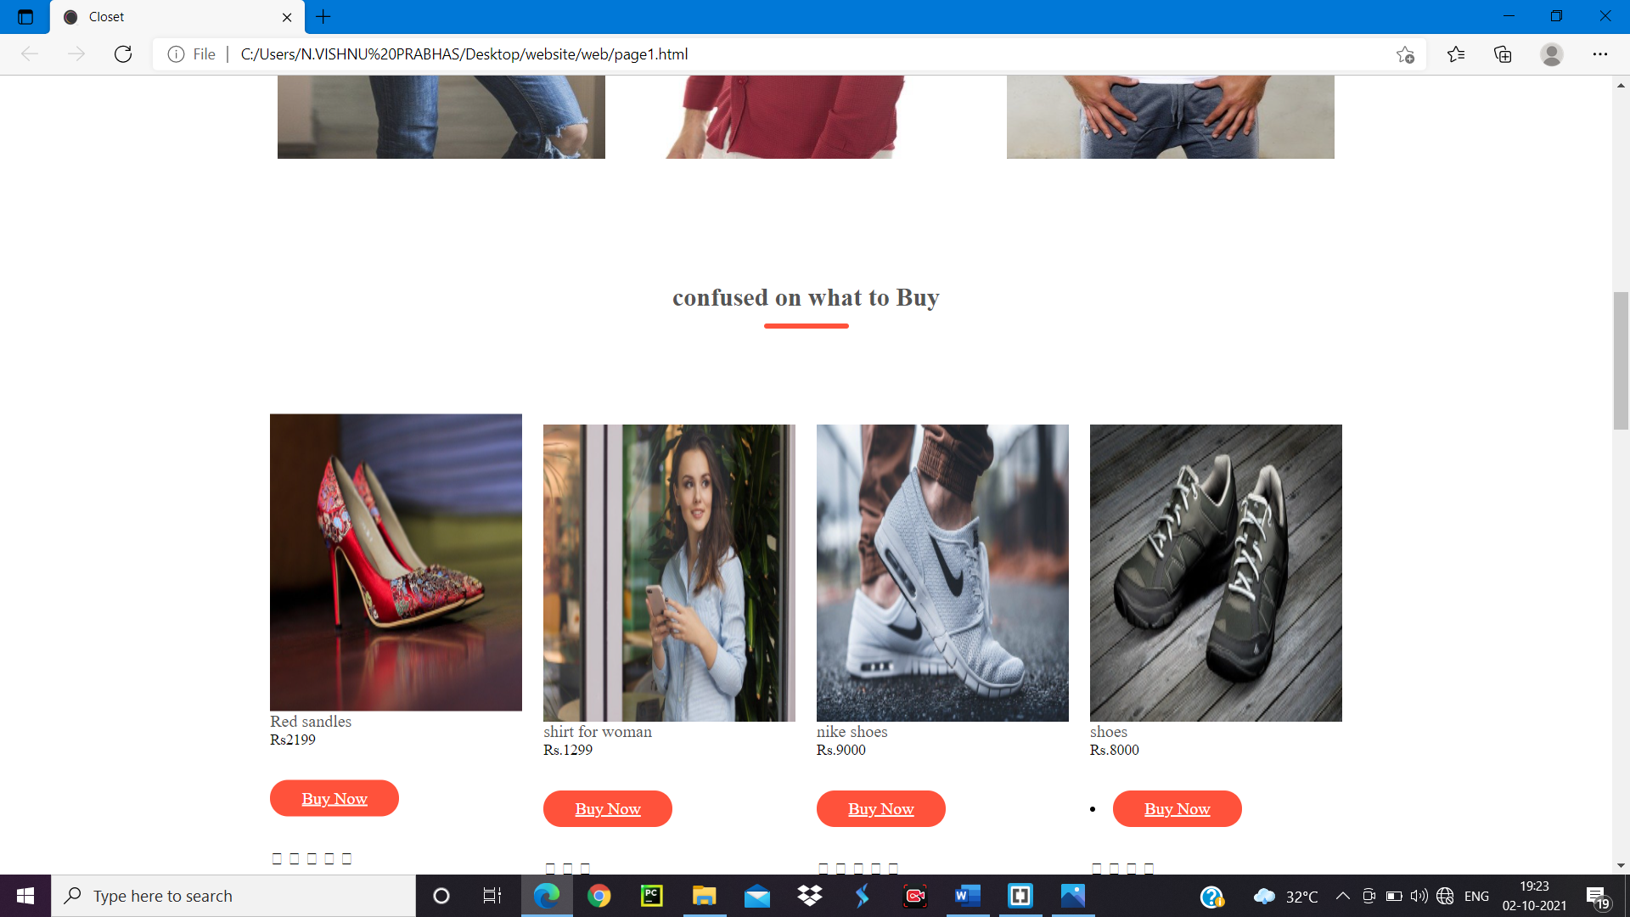

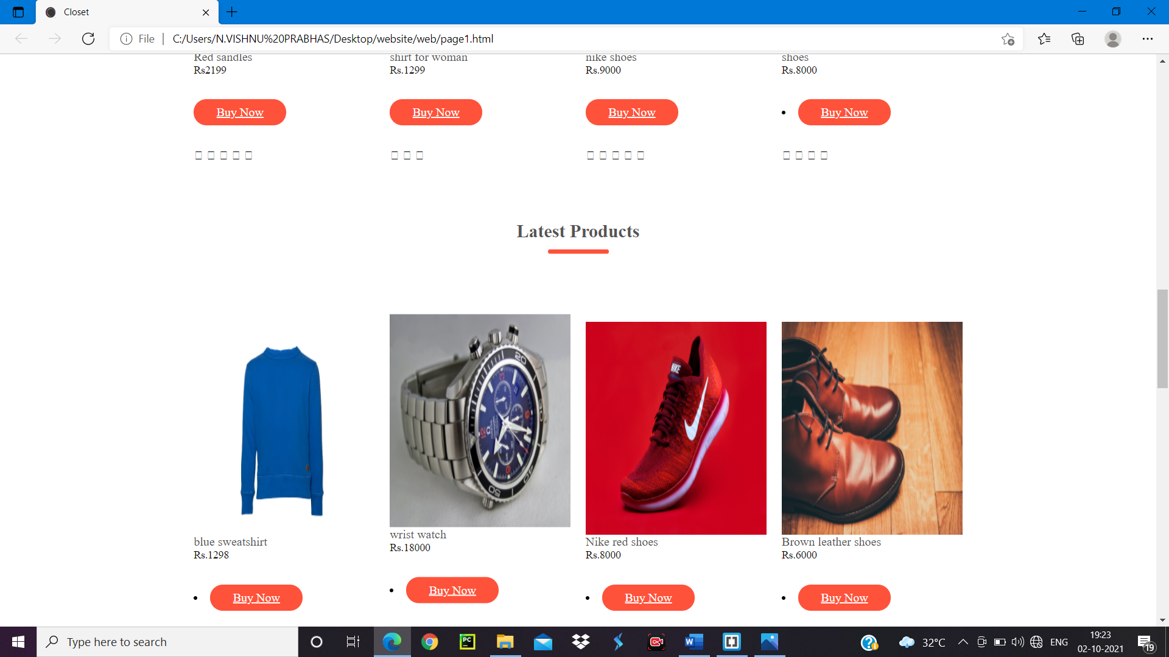

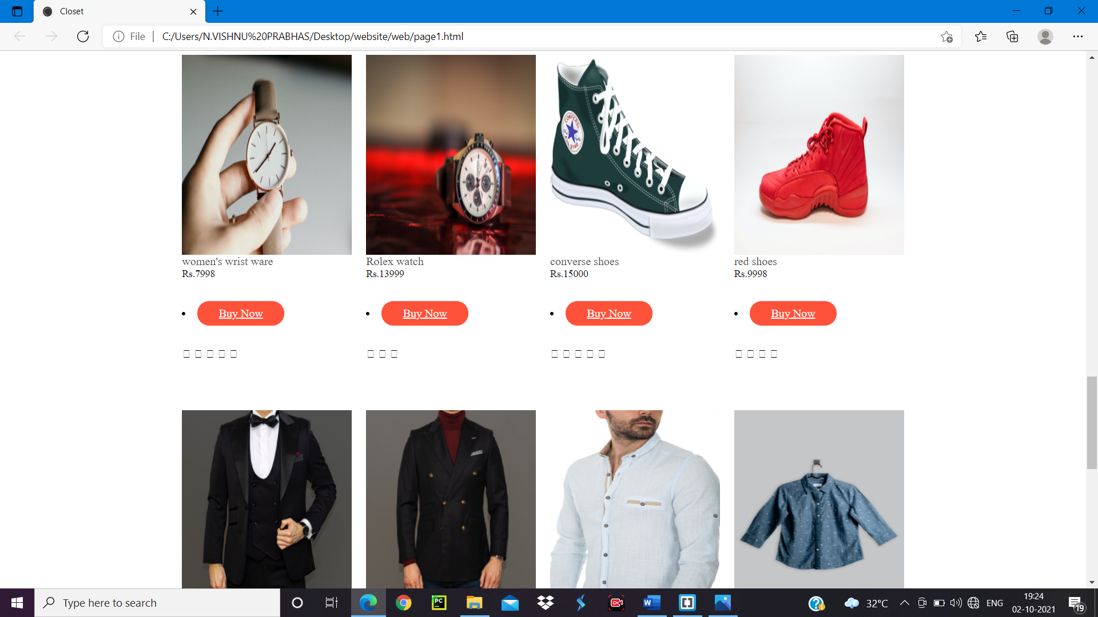

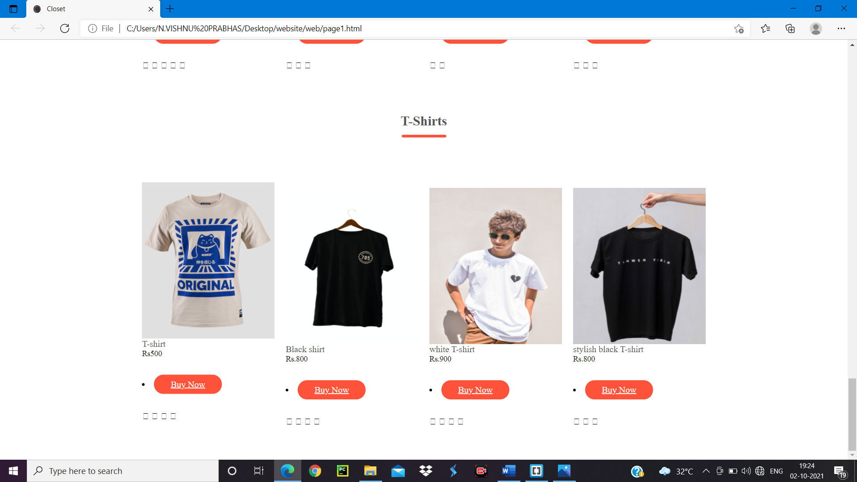

**Screenshot of address updating page:**

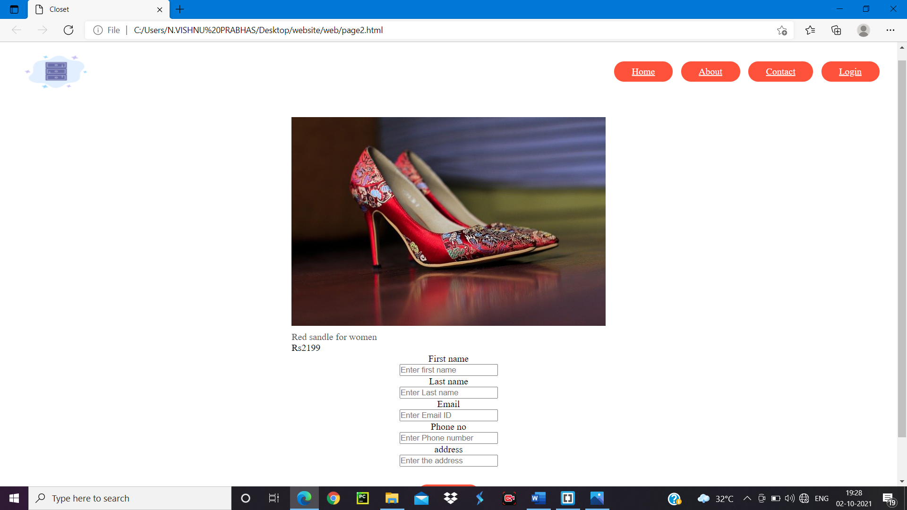

**7.References:**

* Material provided by guide
* From Google
* From You tube (<https://youtu.be/yQimoqo0-7g>)
* pngtree.com/so/fashion-logo